The local host folder is Document root: C:/MAMP/htdocs

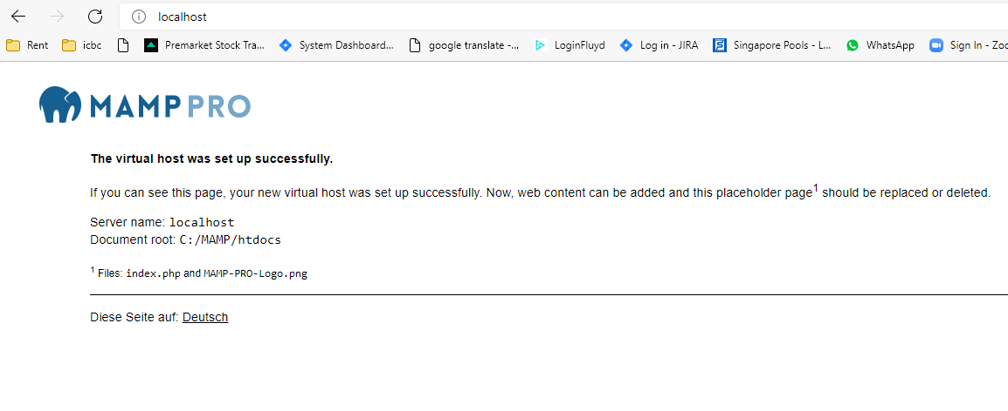

After importing:

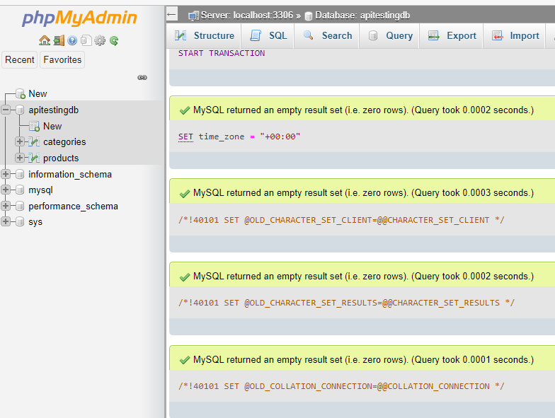

After copy “api_testing” folder to local host folder:

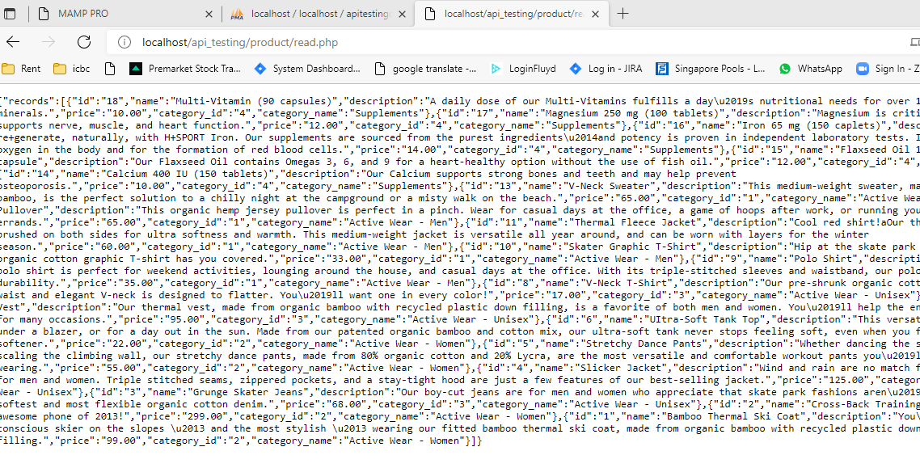

Query database to get product Id – select DB, click SQL tab, execute select command.

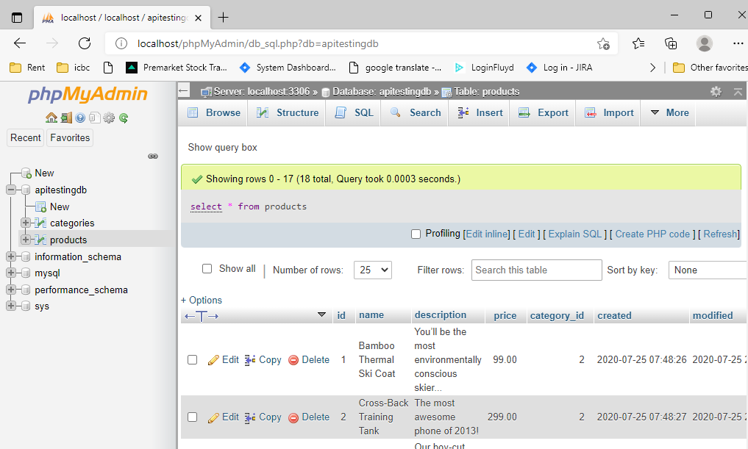

Generate getter and setter in IntelliJ : right click -> click Generate> choose getter and setter option.

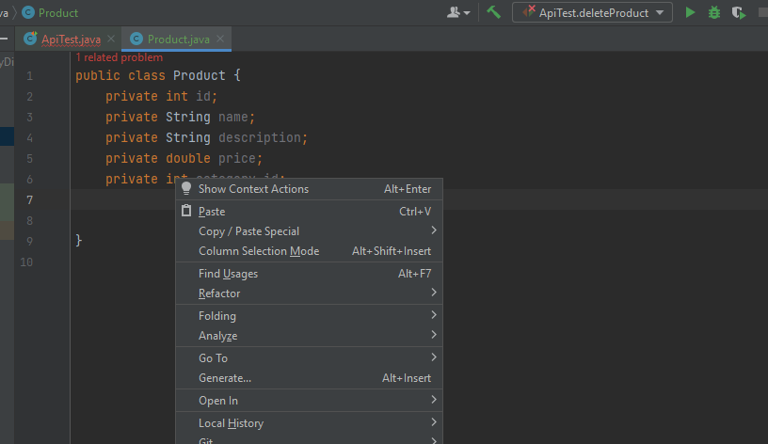

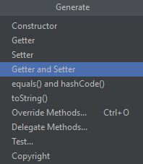

A full life cycle of a resource: creating, viewing, updating and deleting a product.



